Storyboarding
When a script is written for a film or animation, the next step is to make a storyboard. A storyboard visually tells the story of an animation panel by panel, kind of like a comic book. Basically, before you start a work you may need to make a plan to predict required materials and time. It is same but with more details.
Your storyboard will should convey some of the following information:
What characters are in the frame, and how do they move?
What are the characters saying to each other, if anything?
How much time has passed between the last frame of the storyboard and the current one?
Where the "camera" is in the scene? Close or far away? Is the camera moving?
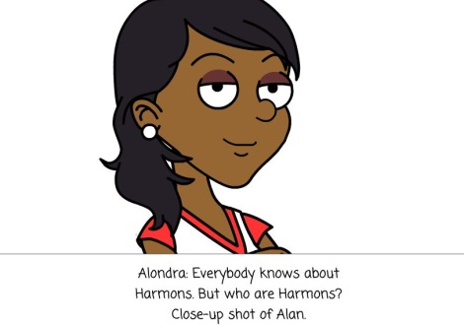 | 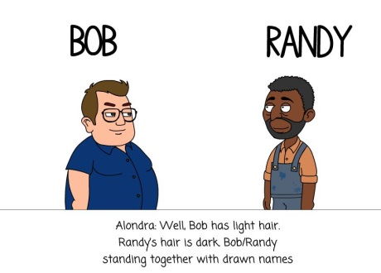
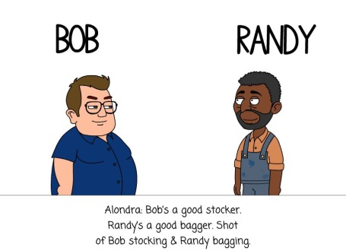 | 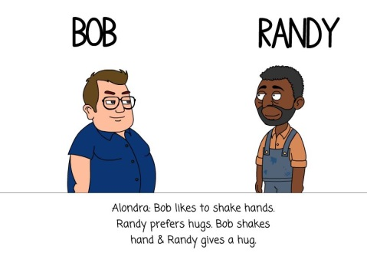
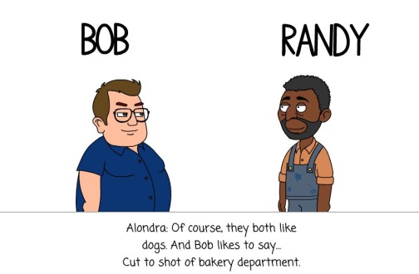 | 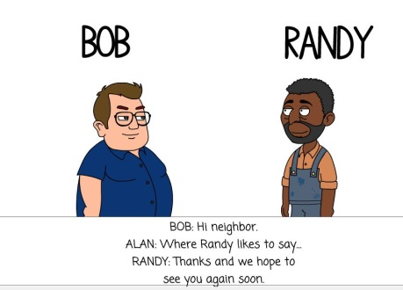
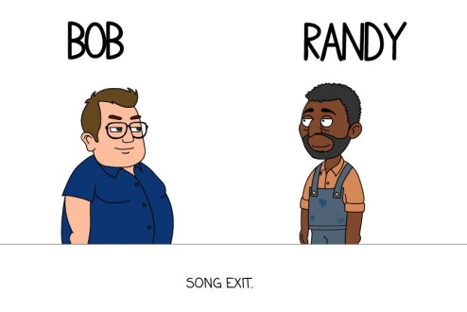 | You may find more details on my PBL site and Video.
My Video |  | My Website

